**BudTrack User Manual**

**Table of Contents**

* **Introduction**
* **Installation Guidelines**
* **Login/Register**
* **Budget Tracker**

# What is BudTrack

BudTrack is an expense manager for use as a Desktop Application built using Python.

BudTrack also allows you to :-

* Login/Register:You can store all your expenses at one place i.e. your account. With BudTrack , you can easily create an account for free and start managing your finances!
* Budget Tracker : You can add budgets and expenses, view them in a tabular format and also represent your remaining money in the form of a pie chart.

# 

# How to Install and Run

After installing python we need to install to additional packages

1) Matplotlib which is used to display the pie chart of the money spent and money left.

Run the following command in cmd to install

pip install matplot lib

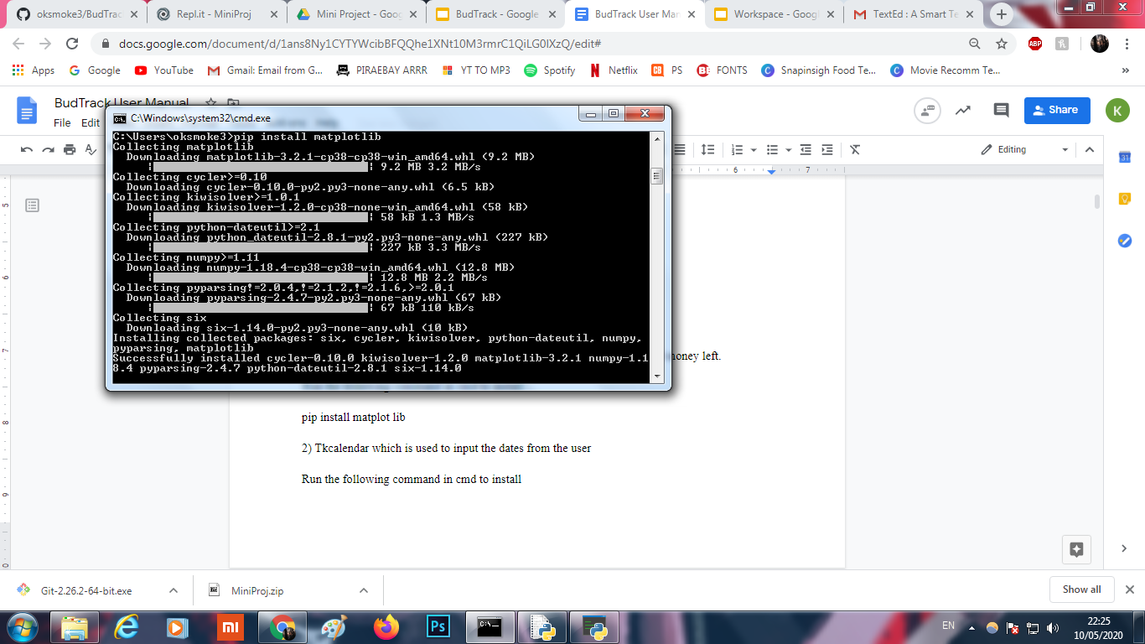

2) Tkcalendar which is used to input the dates from the user

Run the following command in cmd to install

pip install tkcalendar

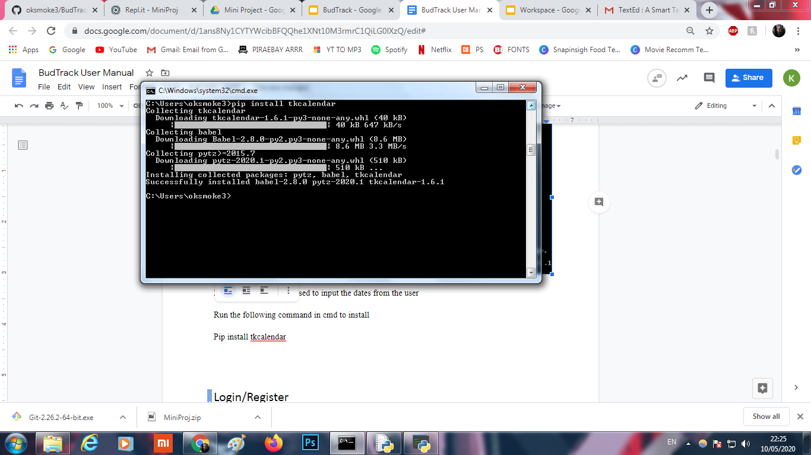

3) Double click on main.py to launch the program

# Login/Register

Before using BudTrack, you need to create an account. Every time you will use BudTrack , you will be prompted to enter your login det.This feature makes your work more secure and protected.

When you run the Python File main.py, you will get the following window:

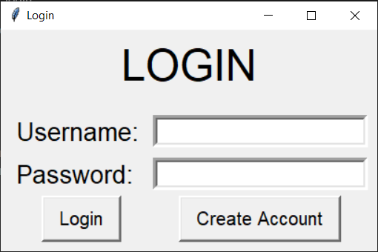

If you have not created an account yet, you need to register first:

To Register:

1. Click ‘Create Account’ Button.
2. Enter the Username and Password.
3. Click ‘Create Account’ Button.
4. You will get the message ‘Account Created Successfully’.
5. Then you will Redirected to the Login Form.

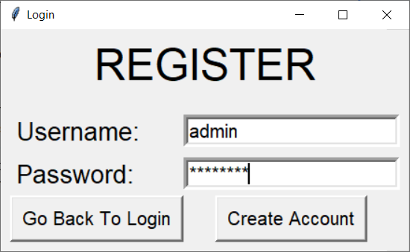

To Login:

1. Enter your Username and Password.
2. Click on the ‘Login’ button.
3. After successful login, you will be redirected to the main page.

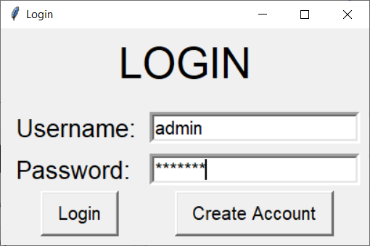

After a successful login you will be directed to the Budget page.

# Budget Tracker

You will see 3 tabs Budget,Expense and Graph.

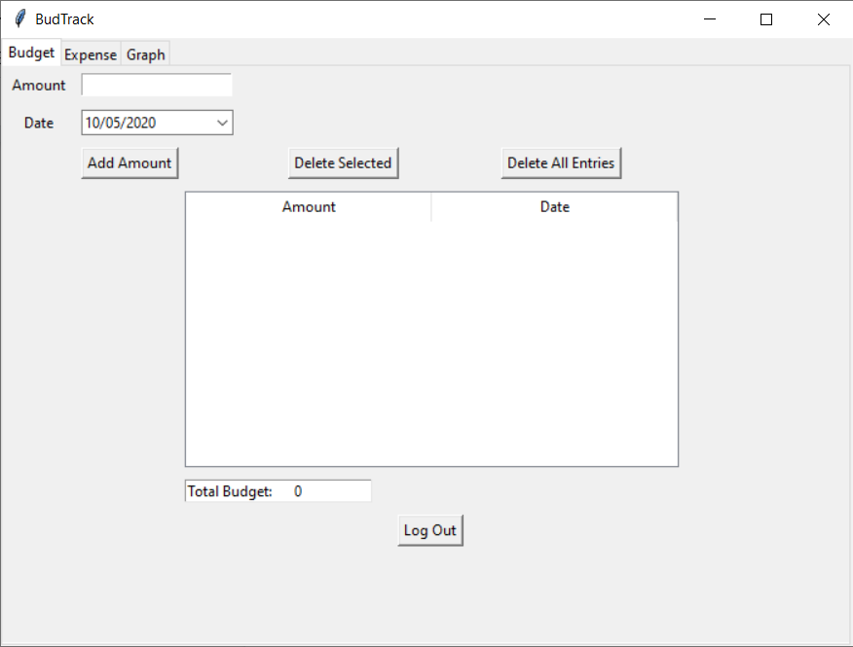

**In the Budget tab**

Adding budget amount:

1. Enter the amount to add
2. Select the date
3. Click on Add Amount
4. Your addition to the budget will be displayed

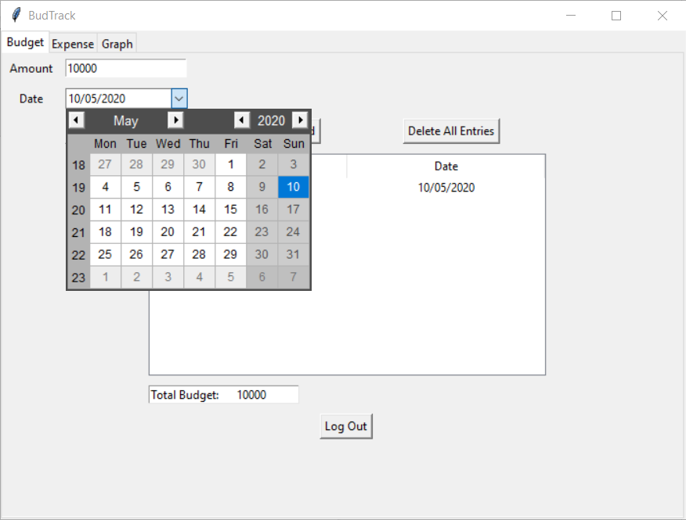

Deleting an entry:

1. Select an entry on the window.
2. Select ‘Delete Selected’ option.
3. The entry gets deleted and the updated budget is displayed.

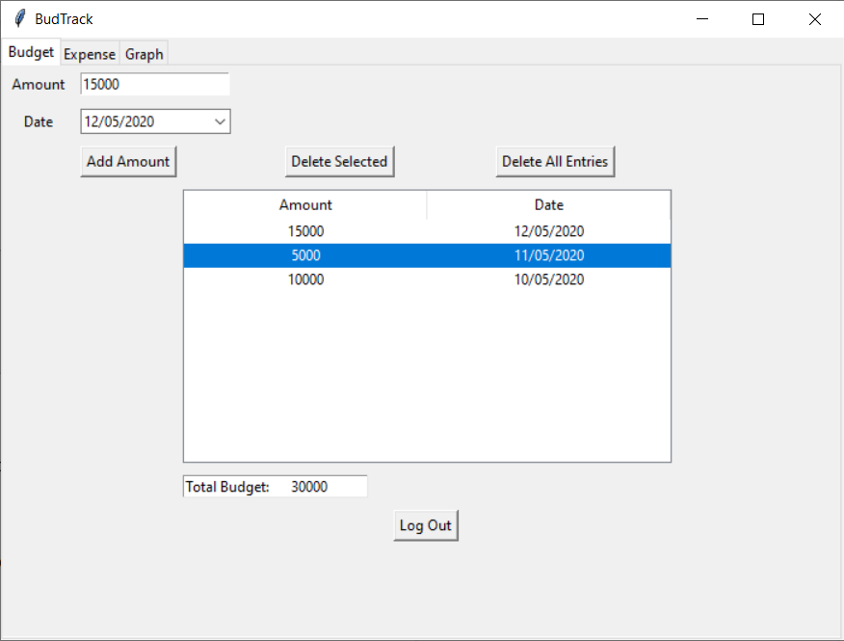

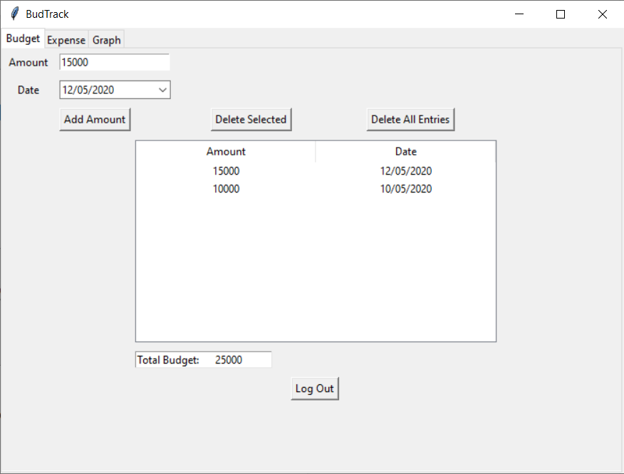

Deleting all entries:

1. Select ‘Delete All Entries’ option.
2. All entries get deleted and the ‘0’ budget is displayed.

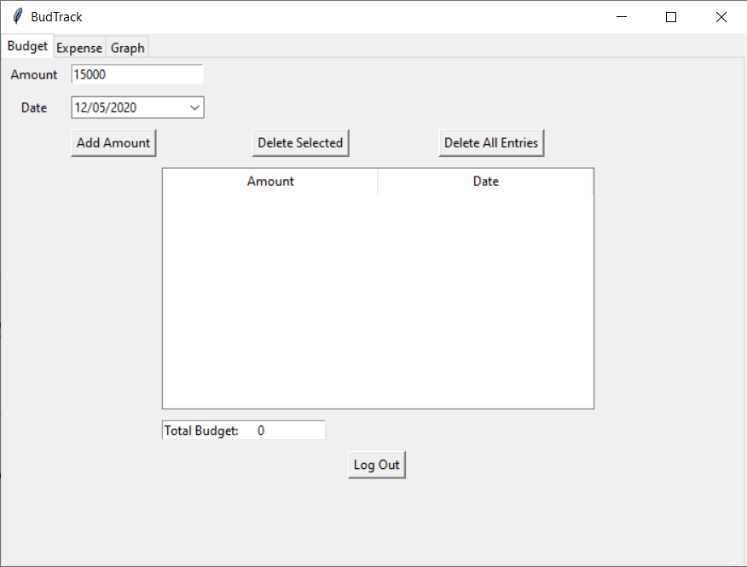

**In the Expense tab**

Adding expense amount:

1. Enter the name of the expense
2. Select the date
3. Enter the amount to add
4. Click on Add Item
5. Your addition to the expense will be displayed

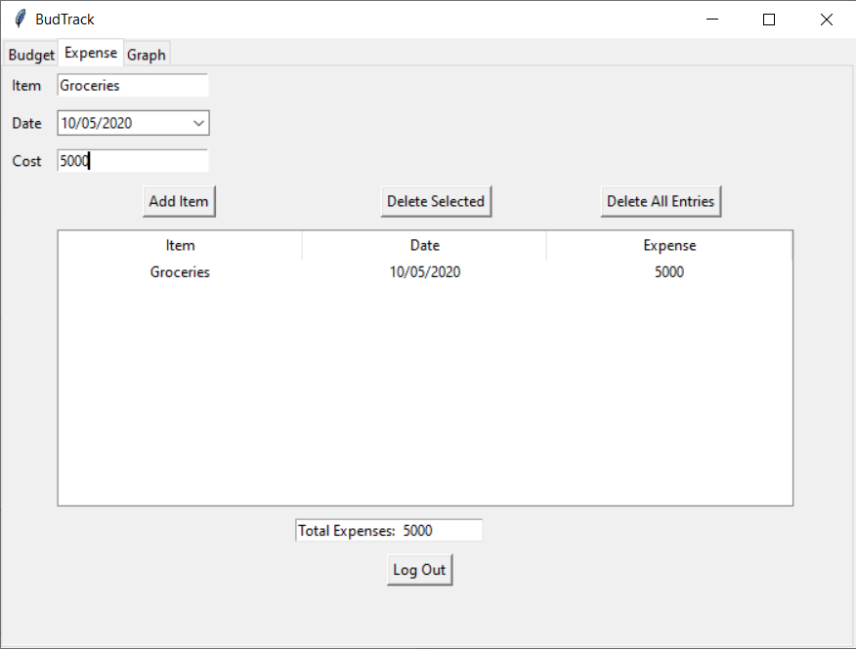

Deleting an entry:

1. Select an entry on the window.
2. Select ‘Delete Selected’ option.
3. The entry gets deleted and the updated total expense is displayed.

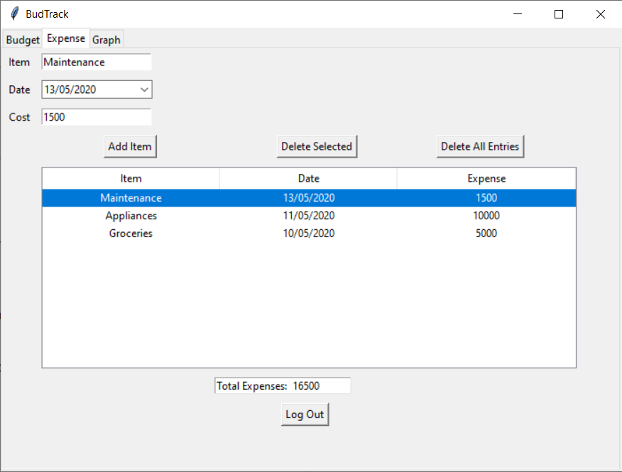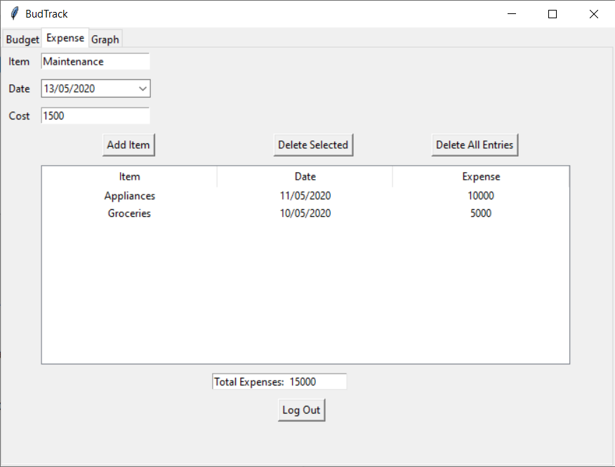

Deleting all entries:

1. Select ‘Delete All Entries’ option.
2. All entries get deleted and the ‘0’ expense is displayed.

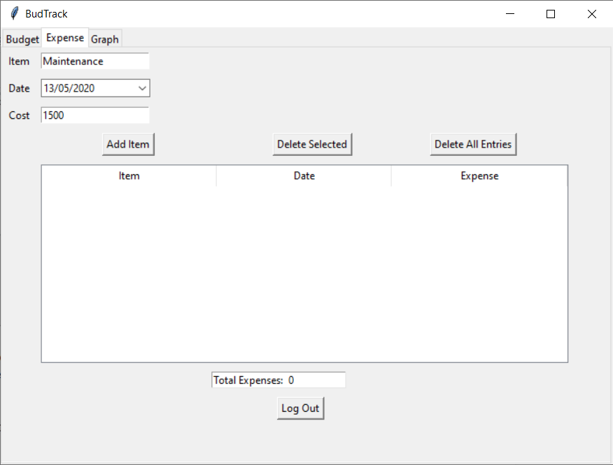

**In the Graph Tab**

To view the amount of money spent and left, click on Graph It!

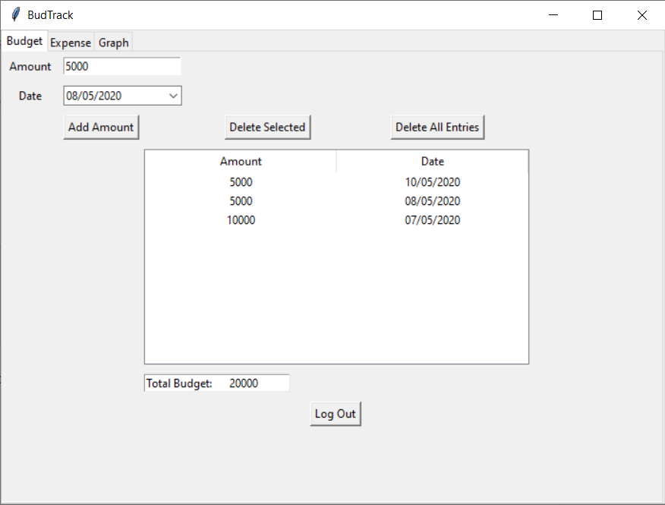

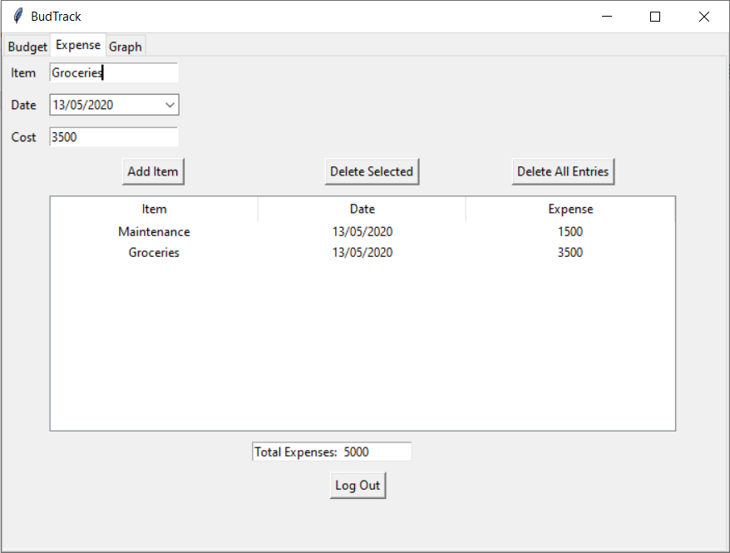

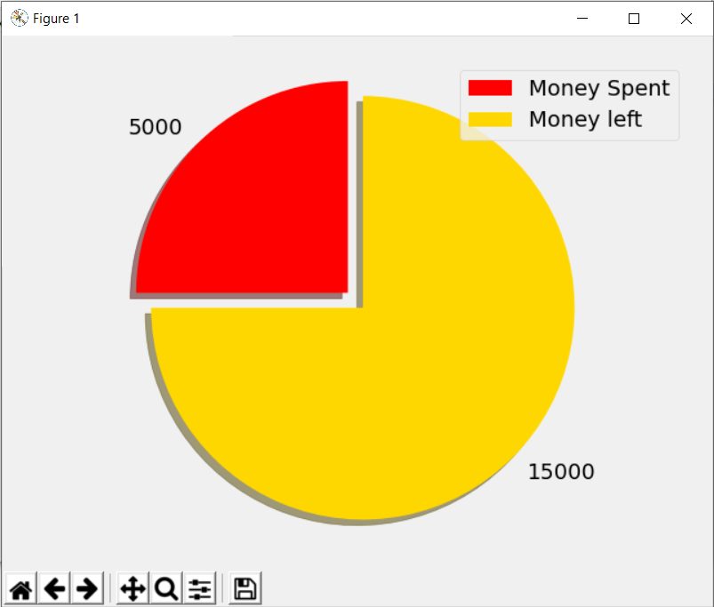

You can pan the graph using the fourth button from the left, in the toolbar at the bottom of the screen.

You can also export the graph as an image file for documentation purposes.